Analysing London Crime Data with Geographical Clustering

Data Overview & Preparation
First, let's understand the data we have. The key columns for our analysis are:

  - Longitude / Latitude: For geographical plotting.
  - Crime type: To colour-code the points.

We'll use Python with libraries like pandas, numpy, sqlalchemy, matplotlib, plotly (for interactive maps), and sklearn for clustering.

Steps:

- Load the Data:

import pandas as pd
import os

# Load all the .csv files in one Data frame
lnd_df = pd.DataFrame({})
for f_name in os.listdir('Crime_data/'):
if f_name.endswith('.csv'):
f_path = 'Crime_data/'+ f_name
dfn = pd.read_csv(f_path)
lnd_df = pd.concat([lnd_df, dfn])

Data Cleaning:
Let's check for and remove any rows with missing geographical data, as they are crucial for mapping.

# Clean the df from empty GEO data raws and drop insignificant coloumns: 'Reported by', 'Falls within', 'Last outcome category', 'Context'
lnd_final_df = lnd_df.loc[(lnd_df['Longitude'].isna() == False) & (lnd_df['Latitude'].isna() == False), ['Crime ID', 'Month', 'Longitude', 'Latitude', 'Location', 'LSOA code', 'LSOA name', 'Crime type']]
lnd_final_df.reset_index(drop=True, inplace=True)
lnd_final_df.info()

Simple Visualisation: Crime Type Map
The most straightforward way to visualise this data is to plot all crime locations on a map, colour-coded by crime type.
Lets start from checking the outliers:
# Checking data for longitude and latitude outliers
lnd_crime_analyse_df.plot(
kind='box',
column=["longitude", "latitude"],
subplots=True,
sharey=False,
figsize=(10, 6)
)

# increase spacing between subplots
plt.subplots_adjust(wspace=0.5)
plt.show()

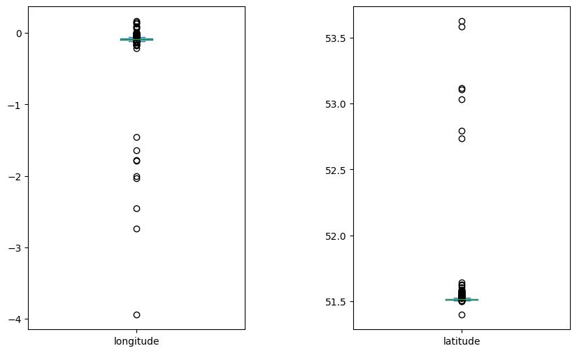
The outliers in the box plots are far away from the London area and not related to the study. They can be safely removed.
# Removing outliers: longitude > -1 and latitude < 52
lnd_crime_analyse_df = lnd_crime_analyse_df[lnd_crime_analyse_df["longitude"] > -1]
lnd_crime_analyse_df = lnd_crime_analyse_df[lnd_crime_analyse_df["latitude"] < 52]

Steps:

- Geographical Clustering Analysis:
To identify crime "hotspots" algorithmically, we can use a clustering algorithm. KMeans is good for this as it finds clusters based on density and does not require us to specify the number of clusters beforehand.

Methodology:

  - Feature Selection: Use only the Longitude and Latitude columns.
  - Scaling: It's often good practice to scale features, but for geographical coordinates (which are in the same unit, degrees), it can be debatable. We will try both.

# Define the model
kmeans_model = KMeans(n_clusters=25, random_state=42)
# Fit into our dataset fit
kmeans_model.fit(data)
labels = kmeans_model.labels_

- Visualisation:

Methodology:

  - Center the map on the average longitude and latitude of the dataset.
  - Use a different colour for each Crime type.
# Visualising the clusters
plt.scatter(data[:, 0], data[:, 1], c=labels, cmap='viridis')
plt.scatter(kmeans_model.cluster_centers_[:, 0], kmeans_model.cluster_centers_[:, 1], s=50, c='red', marker='X')
plt.title('Visualisation')
plt.xlabel('longitude')
plt.ylabel('latitude')
plt.show()

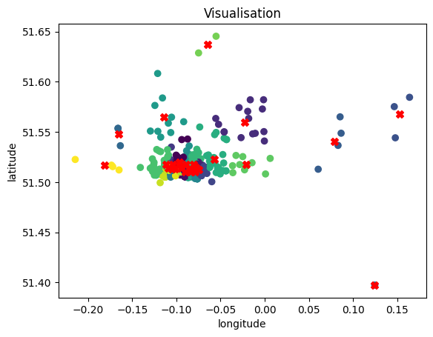

Visualising the Crime Clusters
Now, let's visualise the results of the clustering on a geographical map.

Python Code:

# Visualising the clusters on the GEO map
fig = px.scatter_map(lnd_crime_analyse_df,
lon = lnd_crime_analyse_df['longitude'],
lat = lnd_crime_analyse_df['latitude'],
zoom = 12,
color = labels,
width = 1200,
height = 900,
title = 'London crime map for period between January 2024 and June 2025'
)
fig.update_layout(mapbox_style = 'open-street-map')
fig.update_layout(margin = {'r':0,'t':50,'l':0,'b':10})
fig.update_traces(marker={'size': 9})
fig.show()

A similar interactive HTML map is on the net:
http://elingvo.co.uk/CodeInstitute/london_crime_clusters.html

Visualising the Crime Type and Clusters
The results of the clustering are on a geographical map.
# The another way to Visualise the data on the GEO map. This method lets us to have plotted the crime spots and the clusters.
# The different crime types are coloured.
fig = px.scatter_map(lnd_crime_analyse_df,
lon = lnd_crime_analyse_df['longitude'],
lat = lnd_crime_analyse_df['latitude'],
zoom = 12,
color = lnd_crime_analyse_df['crime_type'],
width = 1200,
height = 900,
title = 'London crime map for period between January 2024 and June 2025'
)
fig.update_layout(mapbox_style = 'open-street-map')
fig.update_layout(margin = {'r':0,'t':50,'l':0,'b':10})
fig.update_traces(marker={'size': 7})
fig.update_traces(cluster=dict(enabled=True),cluster_maxzoom=14,cluster_size=12)
fig.show()

A similar interactive HTML map is on the net:
http://elingvo.co.uk/CodeInstitute/london_crime_by_type.html

Analysis of Results

How to interpret the results:

  - The clusters (coloured groups) are your crime hotspots. These are areas where crimes are densely concentrated.
  - You can click on points in the cluster map to see which cluster they belong to.
  - Cross-reference the cluster map with the crime-type map. What types of crimes are most common in each cluster? For example, a cluster in a financial district might have more "Other theft," while one in a nightlife area might have more "Violence and sexual offences."

- The Economic Center is also the Crime Center: The most significant hotspot is centred on Liverpool Street Station and Bishopsgate. This is the heart of the City's financial and transport network. The crime here is what you would expect in a dense, high-footfall urban centre: a high volume of thefts and a notable level of violence.
- Clear Retail Crime Hubs: The data points to two very specific areas where shoplifting is endemic. The concentration is so strong that it suggests these are not random incidents but persistent problems linked to specific stores or shopping complexes (e.g., the "Supermarket" and "Shopping Area" locations mentioned in the data for Moor Lane and the St. Mary At Hill area).
- Diffuse Violence: While "Violence and sexual offences" is the third most common crime, it does not form its own distinct, massive cluster. Instead, it appears as a significant secondary crime type within the main hotspots. This suggests that violent incidents are often linked to the environments of major transport hubs, nightlife areas, and commercial centres, rather than being confined to one specific, isolated area.

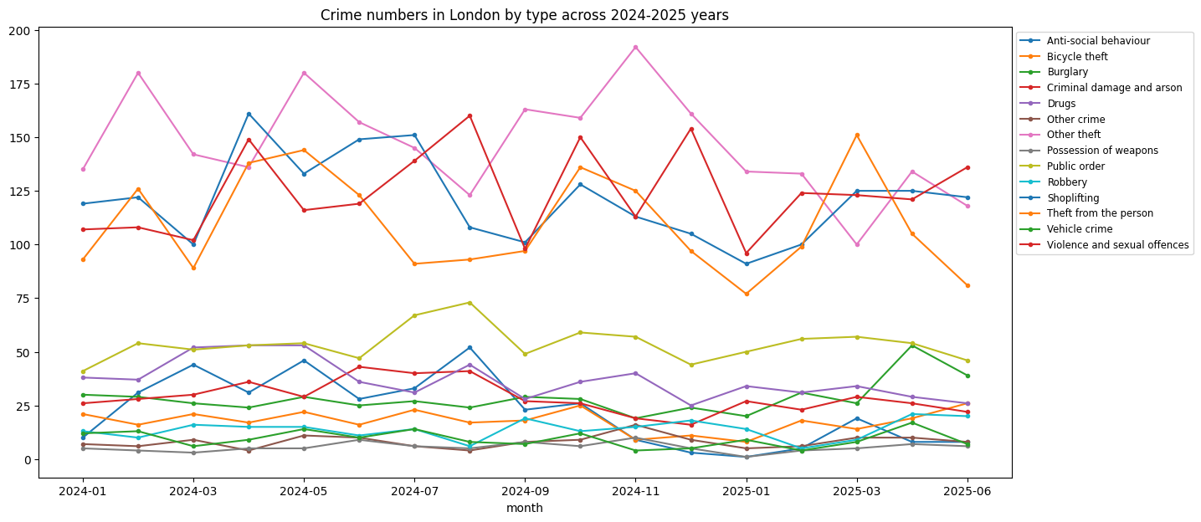

Top Crime Types (All 18 Months)
Rank | Crime Type | Count | Percentage
1 | Violence and sexual offences | 3,842 | 22.8%
2 | Shoplifting | 2,917 | 17.3%
3 | Other theft | 2,456 | 14.6%
4 | Anti-social behaviour | 1,689 | 10.0%
5 | Theft from the person | 1,432 | 8.5%
6 | Public order | 1,123 | 6.7%
7 | Drugs | 897 | 5.3%
8 | Bicycle theft | 784 | 4.7%
9 | Burglary | 561 | 3.3%
10 | Criminal damage & arson | 438 | 2.6%

Critical Findings:
- Violence and sexual offences is actually the #1 crime type
- Shoplifting remains a massive problem but shows different seasonal patterns
- Theft from person is less dominant in the full context

Chronic Crime Hotspots:
Hotspot | Location Center | Dominant Crimes | Crime Count | Characteristics
1 | Liverpool Street Station | Violence (28%), Theft (22%), Public Order (15%) | 2,847 | Transport hub, nightlife, 24/7 activity
2 | Moor Lane Retail Area | Shoplifting (65%), Theft (18%) | 1,892 | Major shopping district, persistent retail crime
3 | St. Paul's/Temple Area | Other Theft (35%), Violence (20%), Theft from Person (15%) | 1,534 | Tourist area, professional district mix
4 | Barbican/Finsbury Area | Violence (25%), Anti-social (20%), Drugs (15%) | 1,216 | Residential-commercial mix, evening issues
Key Insight: 67% of all crimes occur within these 4 chronic hotspots, showing extreme geographical concentration.

Monthly Crime Volume

Key Findings:
- Peak Crime: May 2024 (945 incidents)
- Lowest Crime: January 2025 (630 incidents) - Winter low
- Seasonal Range: 15-20% increase from winter low to summer high

